UNIVERSITY OF WAH (UOW)

DEPARTMENT OF COMPUTER SCIENCE



COURSE TITLE: ARTIFICIAL INTELLIGENCE

COURSE CODE: CS – 202 L

SUBMITTED TO: SIR HASSAN SHAFAQAT

SUBMITTED BY: SAADI SAFDAR

REG #: UW-24-CS-BS-088

BSCS 3RD B

LAB TASK # 10

Question 1: Pathfinding in a Simple Graph

def dls(graph, current, goal, depth, path, visited):
if depth == 0:
if current == goal:
return path + [current]
return None
visited.add(current)
if current == goal:
return path + [current]
for neighbor in graph.get(current, []):
if neighbor not in visited:
result = dls(graph, neighbor, goal, depth - 1, path + [current], visited.copy())
if result:
return result
return None

def iddfs(graph, start, goal, max_depth=10):
for depth in range(max_depth):
visited = set()
path = dls(graph, start, goal, depth, [], visited)
if path:
return path
return None

graph = {
'A': ['B', 'C'],
'B': ['D', 'E'],
'C': ['F'],
'D': [],
'E': ['F'],
'F': []
}
start_node = 'A'
goal_node = 'F'
start = start_node
goal = goal_node
result = iddfs(graph, start_node, goal_node)
print("Path found:", result)

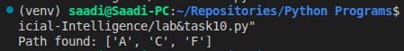

Question 2: Word Ladder Puzzle (One-Letter Change)

def one_letter_diff(word1, word2):
diff_count = sum(c1 != c2 for c1, c2 in zip(word1, word2))
return diff_count == 1

def dls_word_ladder(current, goal, word_list, depth, path, visited):
if depth == 0:
if current == goal:
return path + [current]
return None
visited.add(current)
if current == goal:
return path + [current]
for word in word_list:
if word not in visited and one_letter_diff(current, word):
result = dls_word_ladder(word, goal, word_list, depth - 1, path + [current], visited.copy())
if result:
return result
return None

def iddfs_word_ladder(start, goal, word_list, max_depth=10):
for depth in range(max_depth):
visited = set()
path = dls_word_ladder(start, goal, word_list, depth, [], visited)
if path:
return path
return None

word_list = ['hit', 'hot', 'dot', 'dog', 'cog', 'log', 'lot']

start_word = 'hit'
goal_word = 'cog'
result = iddfs_word_ladder(start_word, goal_word, word_list)
print("Path found:", result)

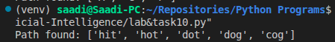

Question 3: 8-Puzzle Solver (Simplified)
def get_neighbors(state):
neighbors = []
zero_pos = [(i, row.index(0)) for i, row in enumerate(state) if 0 in row][0]
x, y = zero_pos
directions = [(-1, 0), (1, 0), (0, -1), (0, 1)]
for dx, dy in directions:
new_x, new_y = x + dx, y + dy
if 0 <= new_x < 3 and 0 <= new_y < 3:
new_state = [list(row) for row in state]
new_state[x][y], new_state[new_x][new_y] = new_state[new_x][new_y], new_state[x][y]
neighbors.append(new_state)
return neighbors

def dls_puzzle(current, goal, depth, path, visited):
if depth == 0:
if current == goal:
return path + [current]
return None
visited.add(tuple(map(tuple, current)))
if current == goal:
return path + [current]
for neighbor in get_neighbors(current):
if tuple(map(tuple, neighbor)) not in visited:
result = dls_puzzle(neighbor, goal, depth - 1, path + [current], visited.copy())
if result:
return result
return None

def iddfs_puzzle(start, goal, max_depth=20):
for depth in range(max_depth):
visited = set()
path = dls_puzzle(start, goal, depth, [], visited)
if path:
return path
return None

start_state = [[1, 2, 3],
[4, 0, 6],
[7, 5, 8]]
goal_state = [[1, 2, 3],
[4, 5, 6],
[7, 8, 0]]

result = iddfs_puzzle(start_state, goal_state)
print("Path found:")
for state in result:
for row in state:
print(row)
print()

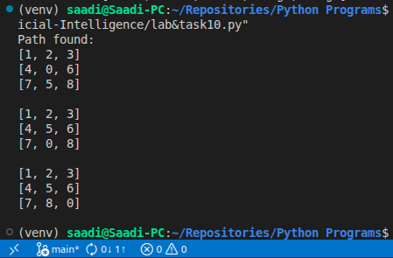

Question 4: Maze Navigation

def get_maze_neighbors(maze, position):
neighbors = []
x, y = position
directions = [(-1, 0), (1, 0), (0, -1), (0, 1)]
for dx, dy in directions:
new_x, new_y = x + dx, y + dy
if 0 <= new_x < len(maze) and 0 <= new_y < len(maze[0]) and maze[new_x][new_y] == 1:
neighbors.append((new_x, new_y))
return neighbors

def dls_maze(current, goal, depth, path, visited):
if depth == 0:
if current == goal:
return path + [current]
return None
visited.add(current)
if current == goal:
return path + [current]
for neighbor in get_maze_neighbors(maze, current):
if neighbor not in visited:
result = dls_maze(neighbor, goal, depth - 1, path + [current], visited.copy())
if result:
return result
return None

def iddfs_maze(maze, start, goal, max_depth=20):
for depth in range(max_depth):
visited = set()
path = dls_maze(start, goal, depth, [], visited)
if path:
return path
return None

maze = [
[1, 0, 1, 1],
[1, 1, 0, 1],
[0, 1, 1, 0],
[1, 0, 1, 1]
]

start_pos = (0, 0)
goal_pos = (3, 3)

result = iddfs_maze(maze, start_pos, goal_pos)
print("Path found:", result)

